
Imputation

Instructions:
Please share your answers filled inline in the word document. Submit code files wherever applicable.

Please ensure you update all the details:
Name: ___G RUPAK______________________
Batch Id: ___07\05\21____________________
Topic: Data Pre-Processing

Problem Statement:
Majority of the datasets have missing values, that might be because the data collected were not at regular intervals or the breakdown of instruments and so on. It is nearly impossible to build the proper model or in other words, get accurate results. The common techniques are either removing those records completely or substitute those missing values with the logical ones, there are various techniques to treat these types of problems.
- Prepare the dataset using various techniques to solve the problem, explore all the techniques available and use them to see which gives the best result.
Hint: Go through this link: https://360digitmg.com/mindmap-data-science

import numpy as np
import pandas as pd

# load the dataset
# use modified ethnic dataset
# df_raw = pd.read_csv('C:/Data/ethnic diversity.csv') # raw data without doing any modifications
df = pd.read_csv('D:/Data Science/ASSIGNMENT/Assignments 3/DataSets/claimants.csv') # for doing modifications

# check for count of NA'sin each column
df.isna().sum()

# Create an imputer object that fills 'Nan' values
# for Mean, Meadian, Mode imputation we can use Simple Imputer or df.fillna()
from sklearn.impute import SimpleImputer

# Mean Imputer
mean_imputer = SimpleImputer(missing_values=np.nan, strategy='mean')
df["CLMAGE"] = pd.DataFrame(mean_imputer.fit_transform(df[["CLMAGE"]]))
df["CLMAGE"].isna().sum()
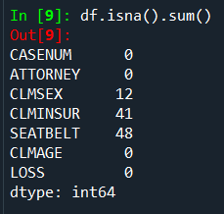

Here I used the mode imputer because data values are categorical.
# Mode Imputer
mode_imputer = SimpleImputer(missing_values=np.nan, strategy='most_frequent')
df["CLMSEX"] = pd.DataFrame(mode_imputer.fit_transform(df[["CLMSEX"]]))
df["CLMINSUR"] = pd.DataFrame(mode_imputer.fit_transform(df[["CLMINSUR"]]))
df["SEATBELT"] = pd.DataFrame(mode_imputer.fit_transform(df[["SEATBELT"]]))
df.isnull().sum()

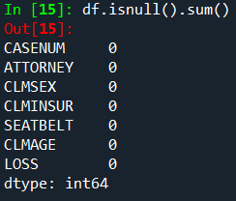

Hints:
For each assignment, the solution should be submitted in the below format
- Work on every feature of the dataset and create a data dictionary as an example displayed in the image below:
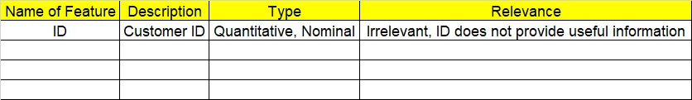
- Hint: Refer to the file Claimants.csv.
- The data is a vehicle Insurance data. Research on the Data fields and perform preliminary analysis
- Research and perform all possible steps for obtaining solution
- All the codes (executable programs) should execute without errors
- Code modularization should be followed
- Each line of code should have comments explaining the logic and why you are using that function

Grading Guidelines:
Note: 1. An Assignment submission is considered complete only when successful executable code(s), and documentation explaining the applied solution and results are provided. Failing to submit either of them will be considered an invalid submission and will not be considered for evaluation.
2. Assignments submitted after the deadline date will affect your grades.

Grading:
Ans | Date |  |  | Ans | Date
Correct | On time | A | 100
80% & above | On time | B | 85 | Correct | Late
50% & above | On time | C | 75 | 80% & above | Late
50% & below | On time | D | 65 | 50% & above | Late
 |  | E | 55 | 50% & below
Copied/No Submission |  | F | 45

- Grade A: (>= 90): When all assignments are submitted on or before the given deadline date
- Grade B: (>= 80 and < 90):
  - When assignments are submitted on time but less than 80% of questions asked in assignments are completed. (or)
  - All assignments were submitted, however, after the given deadline

- Grade C: (>= 70 and < 80):
  - When assignments are submitted on time but less than 50% of questions asked in assignments are completed. (or)
  - Less than 80% of questions asked in assignments are submitted after the deadline

- Grade D: (>= 60 and < 70): Assignments submitted after the Deadline and with 50% or less of questions

- Grade E: (>= 50 and < 60):
  - Less than 30% of questions asked in the assignments are submitted after the deadline (OR)
  - Less than 30% of questions asked in the assignments are submitted before deadline

- Grade F: (< 50): Copied submission or No submission

